Heat equation => ut=c*uxx=c*d^2/dx^2

2 - Heat Equation from Brownian motion, Brownian Motion Interpretation (1D gas)

3 - The continuum limit (Heat equation)

4 - Focker Planck Equation, Heat (Diffusion) Equation

5 - Wave Equation (discrete model), Hamilton’s System

6 - The continuum limit (Wave Equation)

7 - Solving PDEs (simple examples), Heat Equation on R (Scaling,IDEA), dilation scaling

8 - Fundamental solution of the Heat Equation

9 - IVP for Heat Equation ( ut=uxx; u(0,x)=g(x) ), Convolution integral (trick with convolution)

10 - The (Hom) Transport Equation (ut+c*ux=0), Traveling waves, IVP for transport equation

11 - The nonhomogeneous Transport IVP (how to solve + trick)

12 - Wave Equation ( utt=uxx; u(0,x)=u0(x); ut(0,x)=v0(x) ) + how to solve, d'Alambert's Formula (jos)

13 - Linear IVPs and the Fourier Transform

14 – (probabil pentru pagina 13) IDEA: treat evol PDE as ODE in Banach or Hilbert spaces; Heat Equation IVP Example

15 - Lp spaces, All Lp spaces are Banach Spaces, Aprox result C_c dense in Lp(R), L2 is a Hilbert space

16 - Convolution, Fundamental property of convolution, The Fourier Transform, Inverse Fourier transform, chestii cu F(u)(y)

17 - Fundamental properties of Fourier (Plancherel, Shift/ing, Scale/ing, Conjugate, Invariant)

18 - The Fourier Approach, Heat IVP cu delta pentru ca L2, How to apply Fourier

19 - Heat Kernel N(t)(x)={

20 - Linear PDEs in bounded (spatial) domains, Heat Initial Boundary Value Problem (IBVP), Dirichlet Boundary Condition, Heatflow Model

21 - Fourier Approach with BC (Insight 1, Insight 2+ Aim)

22 - Insight 3

23 – Fourier Approach for dimension > 1 (Helmsholz or Dirichlet)

24 - Classical Dirichlet BVP (AIM) vector field scalar field, Laplacian divergence gradient? We call an open set OMEGA of class C if

25 - Classical Integral Calculus Results: Divergence (Gauss-Ostrogradski), Green's Formulae + idea of proof, Gauss

26 - Harmonic functions with radial symmetry EX:21, The fundamental solution of Laplace’s equation, Riemann-Green Formula

27 - (Consequences of Riemann-Green)Mean Value Theorem For Harmonic functions, The Strong Max Principle, The Weak Max Principle

28 - Boundary Value, Dirichlet, Poisson Formula, Dirichlet fresh idea

29 - The Dirichlet Energy Functional, The Dirichlet Principle

30 – The problem with classical solutions, Nonexistance of solutions for optimizing problems, Courant's CounterExample EX:28, Modern Theory IDEA 3 reasons

31 - Weak(Generalized) solutions IF VI HOLDS, Sobolev, H01(omega), H01 Hilbert, The energy norm

32 - H01 analysis possible because Poincare Inequality proof EX:25, C01 dense by construction in H01 Dirichlet Principle in H01, Existence & Uniqueness of a weak sol

33 - Idea of proof for EXISTENCE & UNIQUENESS (Riesz)

34 - List of models: Wave, Damped Wave, Visco-elasticity(linear), Visco-capillarity(1D), Euler-Bernoulli Beam (matrici)

35 - Fisher's Reaction Diffusion (it deals with spatially distributed populations), Fisher KPP, Allen-Cahn, Fisher's model (spatially distributed population),classical population models: Malthus,Verhulst

36 - Fisher's new model (1937) Fisher's Eq, Frick’s law, Fisher’s original question, KPP(Kolmogrov-Petrovsky-P)

37 - Travelling wave sols for fisher eq (TWS) (how to..), Logan (there exists a unique wave profile?)

39 - Reaction diffusion Eq & systems, Examples:Allen-Cahn Eq; Brusselator system, General Reaction diffusion Equilibria(GRDE), Equilibria

40 - Lyapunov Theory, X State Space(Hilbert Space),Dynamical system on X if… , Equilibrium point for , Strict Lyapunov function

41 - La Salle's Invariance Principle, Strict Lyapunov + compact trajectory => convergence to equilibrium

42 - Allen-Cahn Model ( Neumann BC ) + norm

43 - Allen-Cahn Energy is a Lyapunov function

44 - Allen-Cahn convergence to equilibrium

45 - Turing instability, Turing Model(TM), General Reaction Diffusion System(GRDS), stationary solutions, homogeneous stationary solutions

46 – Alan Turing system NEUMAN BC: @math @biology @cs ahead of its time

47 - Turing instability what it means, with diffusion, without diffusion

48 - Turing instability (even more details) ODE System

49 - Turing instability PDE System

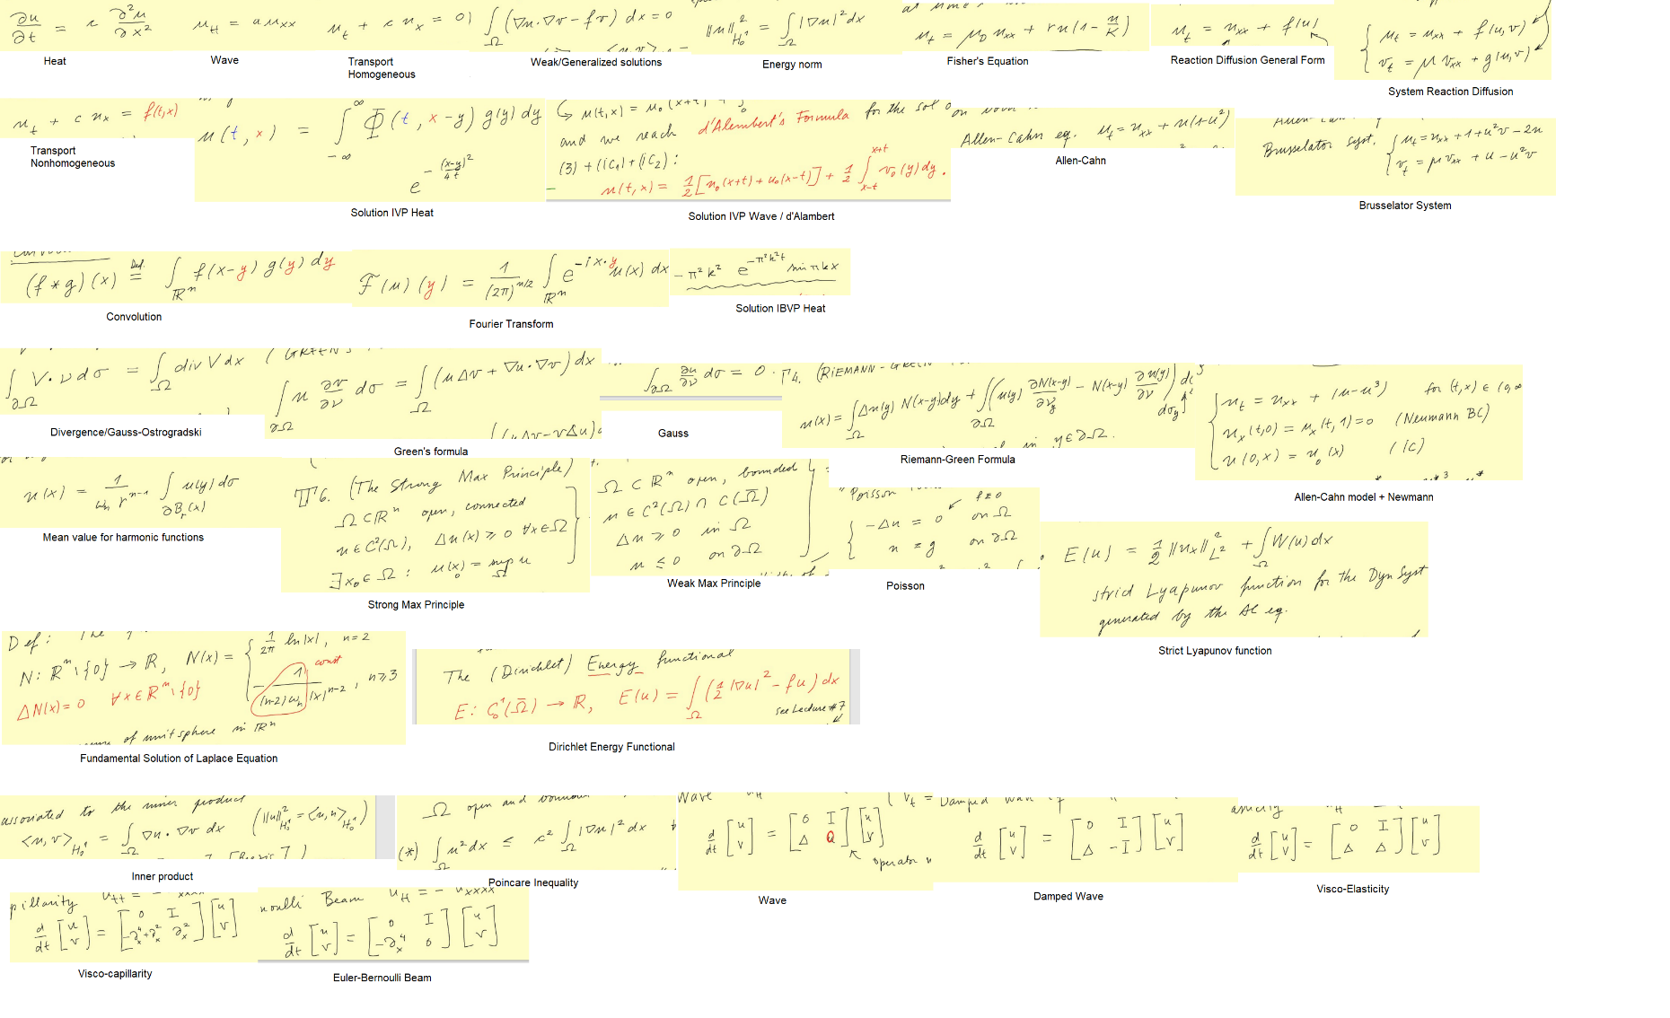FORMULE